**DB Project Part 4 - a**

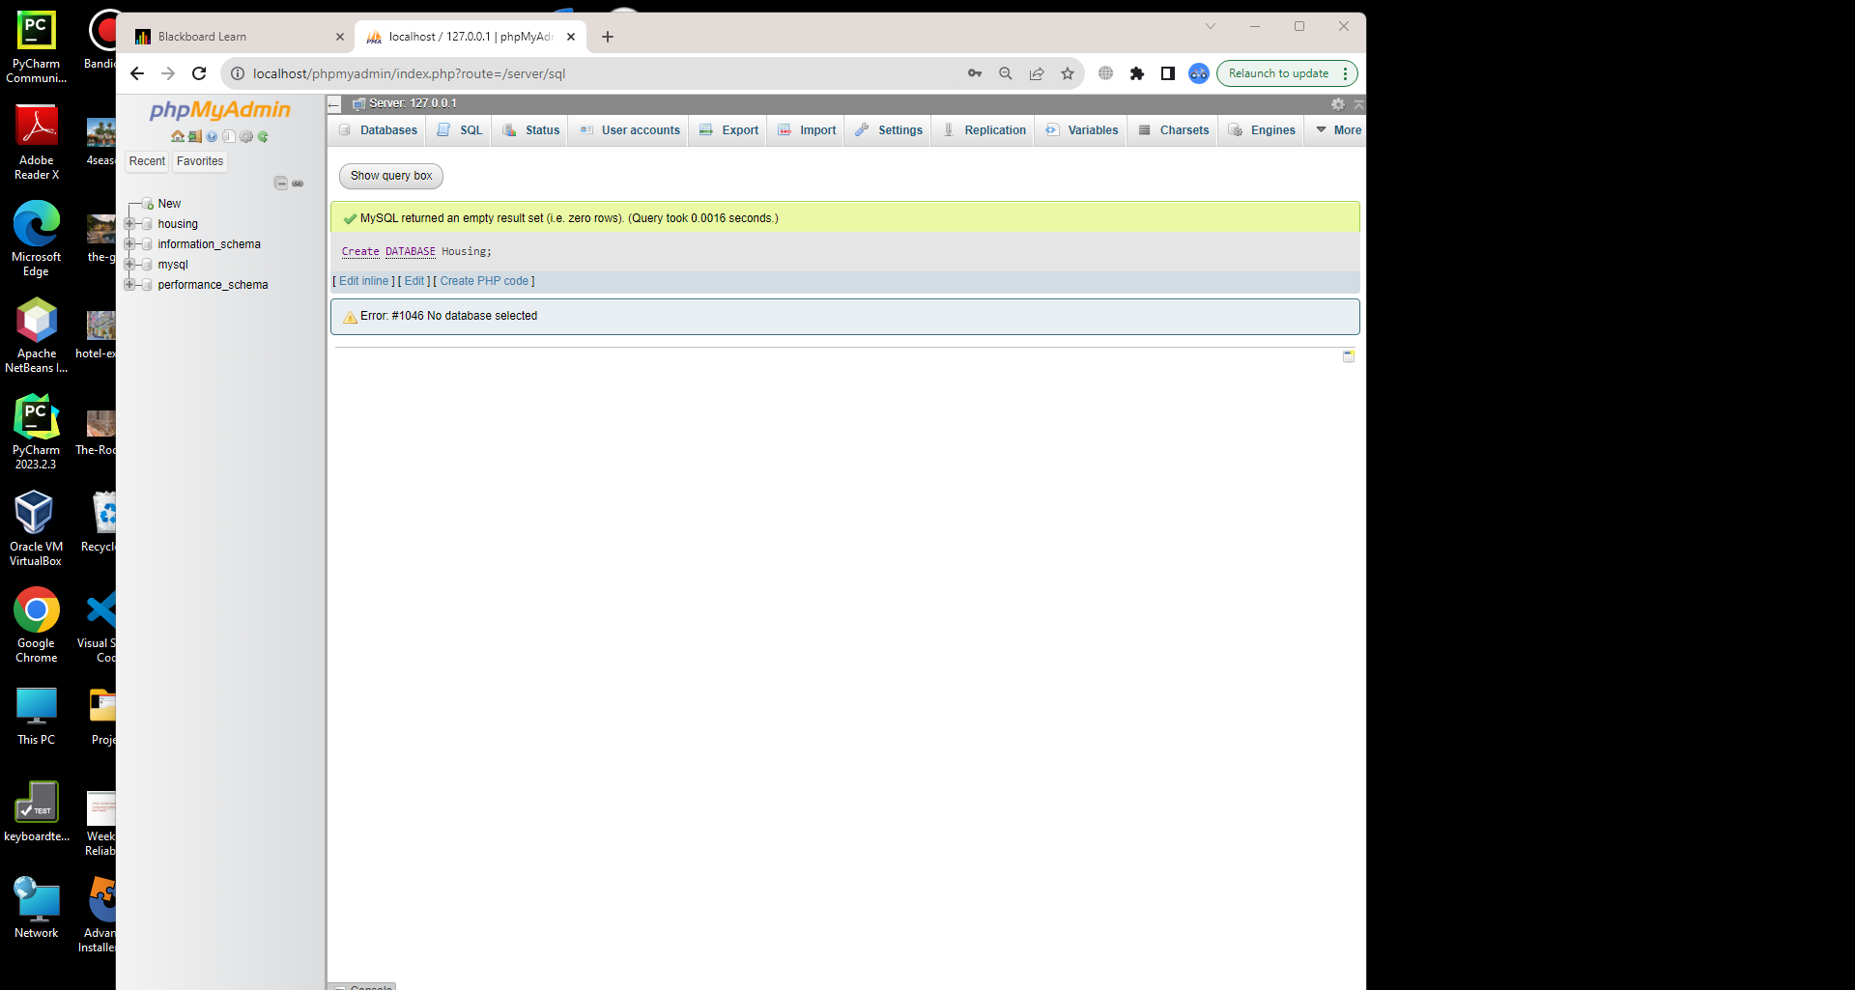

DLL:

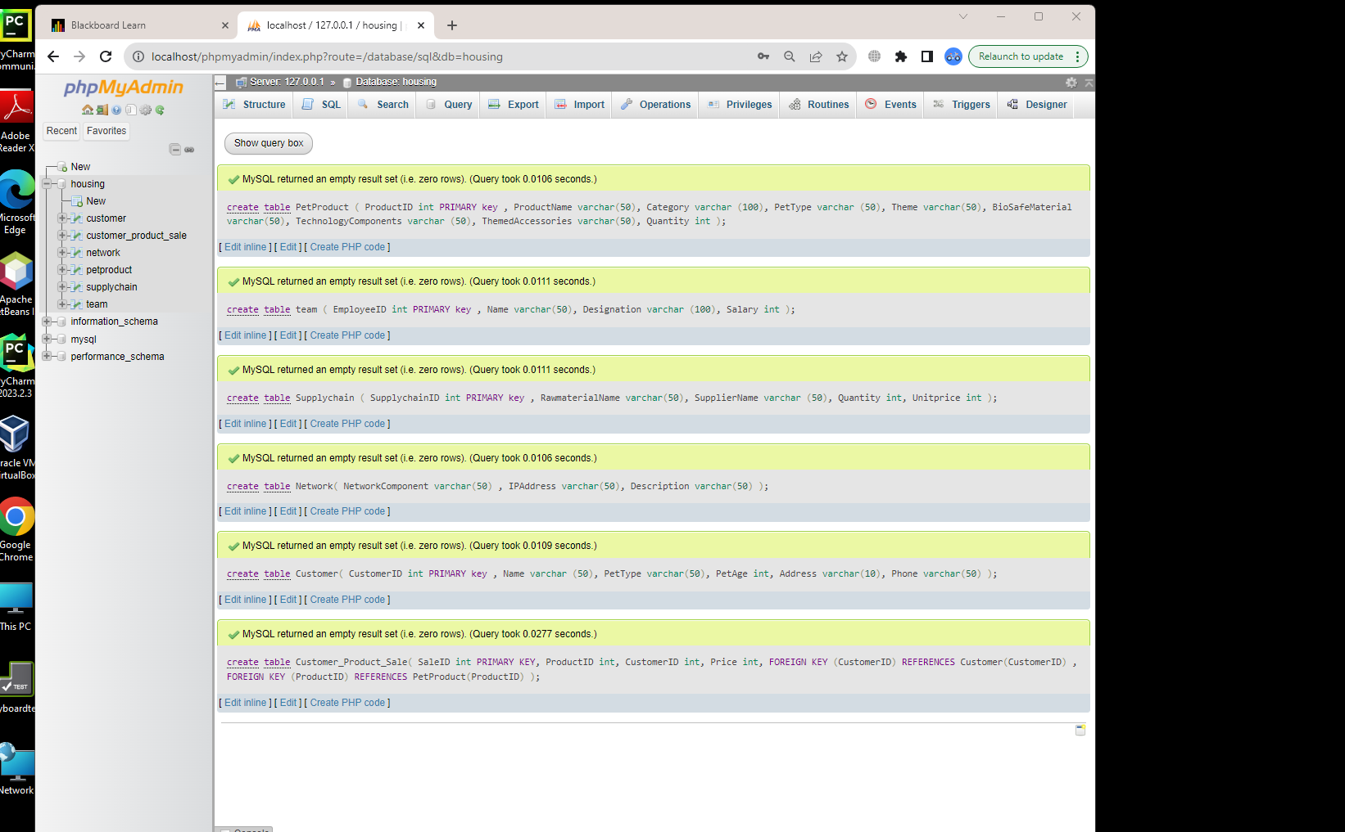

Queries:

create table PetProduct (

ProductID int PRIMARY key ,

ProductName varchar(50),

Category varchar (100),

PetType varchar (50),

Theme varchar(50),

BioSafeMaterial varchar(50),

TechnologyComponents varchar (50),

ThemedAccessories varchar(50),

Quantity int

);

create table team (

EmployeeID int PRIMARY key ,

Name varchar(50),

Designation varchar (100),

Salary int

);

create table Supplychain (

SupplychainID int PRIMARY key ,

RawmaterialName varchar(50),

SupplierName varchar (50),

Quantity int,

Unitprice int

);

create table Network(

NetworkComponent varchar(50) ,

IPAddress varchar(50),

Description varchar(50)

);

create table Customer(

CustomerID int PRIMARY key ,

Name varchar (50),

PetType varchar(50),

PetAge int,

Address varchar(10),

Phone varchar(50)

);

create table Customer_Product_Sale(

SaleID int PRIMARY KEY,

ProductID int,

CustomerID int,

Price int,

FOREIGN KEY (CustomerID) REFERENCES Customer(CustomerID) ,

FOREIGN KEY (ProductID) REFERENCES PetProduct(ProductID)

)

**Load Data Files:**

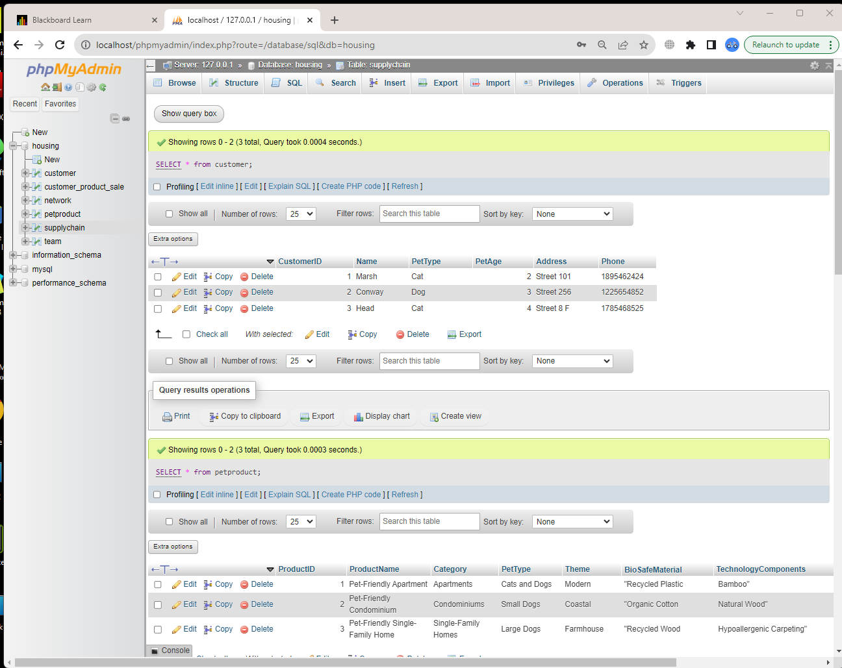

**LOAD Script:**

LOAD DATA INFILE 'D:\PetProduct.csv'

INTO TABLE petproduct

FIELDS TERMINATED BY ','

LINES TERMINATED BY '\n'

IGNORE 1 ROWS;

LOAD DATA INFILE 'D:\SupplyChain.csv'

INTO TABLE supplychain

FIELDS TERMINATED BY ','

LINES TERMINATED BY '\n'

IGNORE 1 ROWS;

LOAD DATA INFILE 'D:\team.csv'

INTO TABLE team

FIELDS TERMINATED BY ','

LINES TERMINATED BY '\n'

IGNORE 1 ROWS;

LOAD DATA INFILE 'D:\Network.csv'

INTO TABLE network

FIELDS TERMINATED BY ','

LINES TERMINATED BY '\n'

IGNORE 1 ROWS;

LOAD DATA INFILE 'D:\Customer.csv'

INTO TABLE customer

FIELDS TERMINATED BY ','

LINES TERMINATED BY '\n'

IGNORE 1 ROWS;

LOAD DATA INFILE 'D:\Customer_Product_Sale.csv'

INTO TABLE customer_product_sale

FIELDS TERMINATED BY ','

LINES TERMINATED BY '\n'

IGNORE 1 ROWS;